OMD- 24 Series
The OMD-24 Bilge Alarm Unit has been designed specifically for use in conjunction with 15 ppm oil-water separator units and has a specification and performance which exceeds the requirements of the International Maritime Organization specifications for 15ppm Bilge Alarms contained in Resolution MEPC. 107 (49).
The unit is supplied with 2 works-adjusted alarms at 15 ppm. Other set points (10 ppm or 5 ppm) are possible and can be adjusted on site at any time by using the buttons at the front panel. If an alarm set point is exceed, the alarms are visible at the front panel and the appropriate relays are switched.
In case of malfunction the System LED at the front panel will change from blinking green to permanent red. For the data logging function the unit requires an status input from the separator. Optionally a 0(4) - 20 mA (equal to 0 - 30 ppm) signal output is available for driving a recorder or external meter.

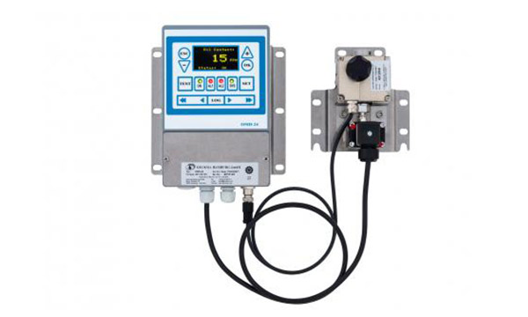

Read more : OMD-24 series

OMD 24

Property Value

Range (measurement & indication) 0 - 30 ppm, Trend up to 50ppm
Range (IMO specification) 0 - 15 ppm (according IMO regulations)
Accuracy better than IMO MEPC.107(49)
Electrical power supply 24V - 240V, AC or DC, Automatic Voltage Selection
Electrical power consumption < 10 VA
Sample Oily water from separator outlet, 0,1 - 4 l/min
Sample temperature range +1°C to +65°C
Sample connections R 1/4" Female
Alarm 1 & 2 Set Points 1 - 15ppm (independently adjustable)
Alarm 1 operating delay for annunciation 1 - 540 sec
Alarm 2 operating delay for control 1 - 10 sec
Alarm contacts 2 independently adjustable switchover contacts
Alarm contact operation mode De-energized in Alarm State
Alarm contact ratings 3A, 240V each
Alarm output 0 - 20 mA or 4 - 20 mA, for 0-30ppm reversible, ext. Load<150Ω
Display Graphic Display
Ambient temperature +1°C to +55°C
Class of protection IP 65
Dimension 360 x 240 x 100 mm (WxHxD)
Weight 5,4 kgs

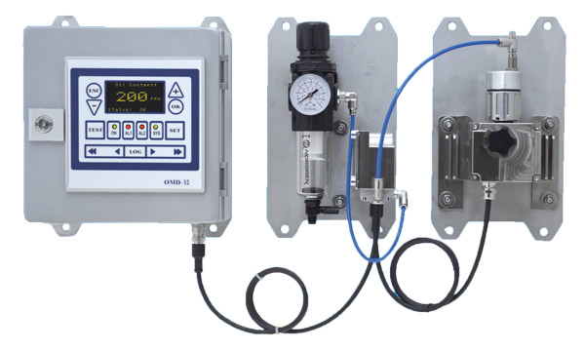
OMD-32 Series

The OMD-32 Oil-in-Water Monitor has been designed specifically for use in conjunction with oil-water separator units.

The OMD-32 has been constructed using technology of the DECKMA HAMBURG OMD series industrial instruments and 15ppm Bilge Alarm Monitors, that have a specification and performance which exceeds the requirements of the International Maritime Organization specifications for 15ppm Oil-in-Water Monitors contained in Resolution MEPC. 107 (49).The OMD-32 unit is supplied with 2 works-adjusted alarms at 10 ppm. Other set points are possible (e.g. 100ppm) and can be adjusted on site at any time by using the buttons at the front panel.If an alarm set point is exceeded, the alarms are visible at the front panel and the appropriate relays are switched. In case of malfunction the System LED at the front panel will change from blinking green to permanent red, and a system fault relay contact is switched.
A 0(4) - 20 mA signal output is available for driving a recorder or external meter.

Read more : OMD-32 series

OMD 32

Property Value

Range* 0 – 200 ppm
Resolution* 1ppm (0.1 ppm below 10ppm)
Accuracy up to +/- 1ppm below 10ppm
Response time < 5s
Sample Water Pressure >max. 10 bar
Sample Flow typ. 2 Liter / min
Sample Water Temperature up to 90° C
Power Supply 24 V – 240V AC or DC
Power Consumption < 10 VA
ppm Alarm 2 adjustable ( independent, entire range )
ppm Alarms delay 2 adjustable ( independent, from 1 sec. up to 540 sec.)
ppm Alarm visual indication 2 Red LEDs
ppm Alarms Contact Rating 2 Potential free 1 pole change over contacts, 3 A / 240 VAC
System Fault Alarm visual indication: Red LED
System Fault Alarm Contact Rating Potential free 1 pole change over contact, 3 A / 240 VAC
Output Signal 0(4) – 20 mA, ext. Load < 150 W, Output range adjustable
Cleaning System* Automatic, pneumatically operated
Cleaning system air pressure* 2.5 - 6 bar, typ. <0.1 Liter / hour
Ambient Temperature + 1 to + 55° C

OMD- 2008 Series

5 ppm + 15 ppm Bilge Alarm according to IMO Resolution MEPC.107 (49)

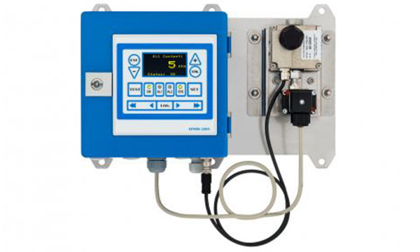
Read more : OMD-2008 series

OMD 2008
Property Value

Range (measurement & indication) 0 - 30 ppm, Trend up to 50ppm
Range (IMO specification) 0 - 15 ppm (according IMO regulations)
Accuracy better than IMO MEPC.107(49)
Electrical power supply 24V - 240V, AC or DC, Automatic Voltage Selection
Electrical power consumption < 10 VA
Sample Oily water from separator outlet, 0,1 - 4 l/min
Sample temperature range +1°C to +65°C
Sample connections R 1/4" Female
Alarm 1 & 2 Set Points 1 - 15ppm (independently adjustable)
Alarm 1 operating delay for annunciation 1 - 540 sec
Alarm 2 operating delay for control 1 - 10 sec
Alarm contacts 2 independently adjustable switchover contacts
Alarm contact operation mode De-energized in Alarm State
Alarm contact ratings 3A, 240V each
Alarm output 0 - 20 mA or 4 - 20 mA, for 0-30ppm reversible, ext. Load<150Ω
Display Graphic Display
Ambient temperature +1°C to +55°C
Class of protection IP 65
Dimension 360 x 240 x 100 mm (WxHxD)
Weight 5,4 kgs

OMD-2008 EV FC MCU with Flow Control
The OMD-2008 EV FC MCU is equipped with a Flow Sensor. The Flow Sensor is positioned in the Drain line of the Measuring Cell.
If the flow rate through the Measuring Cell is too low, or if the sample is not flowing at all, the Instrument will go to Alarm condition and issue a “Status: Flow?” message. According to MEPC.107(49) the 15ppm Bilge Alarm has to be provided with a representative sample, i.e. the operator of the instrument is responsible to maintain a proper sample flow through the instrument. The recommended sample flow rate for Deckma instruments is approx. 2 Liters per Minute. At this flow rate, with a common setup of separator and 15ppm Bilge Alarm, it is easily possible to reliably operate the instrument, and to ensure the required short reaction time to changes in the oil content of the effluent water. The instrument does not know about the sample stream flow rate. If circumstances lead to interruptions of the sample flow, or if the sample flow is stopped completely, the portion of the sample that is in the sample glass tube will be measured continuously. The instrument will display the same measurement result for a long time, but it may fail to adequately react to changes in the overboard discharge water oil content.
For many years the OMD series instruments have had a dedicated input to connect a flow switch to monitor the sample flow rate. However, not many installation have been made with an additional flow switch. A more easy solution had to be found, a solution that does not require additional pipework, or electrical work, on site. The new OMD-2008 EV FC MCU version of the OMD-2008 instrument come with a flow sensor that measures the sample flow rate, and automatically sets the instrument into alarm condition, if a sufficient flow rate is not maintained. Constructed to make accidental flow interruptions, incorrectly closed valves, and a missing sample stream harmless events that do not lead to unlawful discharge, the OMD-2008 EV FC MCU also makes manipulation and tinkering with the instrument setup much less rewarding. Additionally for the OMD-2008 EV FC MCU instruments a Manual Cleaning Unit (MCU) is available. This system allows to quickly clean the sample glass tube without having to open the Measuring Cell. With the MCU maintenance of the system becomes very easy, ensuring high reliability and reduced maintenance workload.

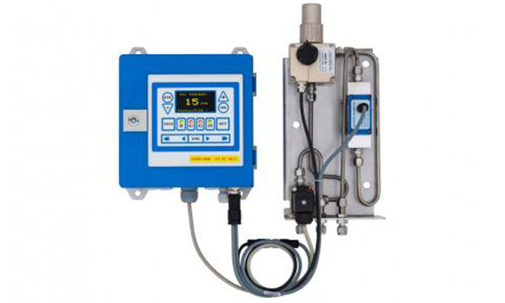
Read more : OMD-2008 EV FC MCU series

OMD 2008 EV FC MCU

Property Value
Range: 0 – 30 ppm, Trend indication 50ppm
Accuracy According IMO MEPC. 107(49)
Linearity: Up to 30 ppm better than ± 2 %
Display: Yellow Graphic Display
Power Supply: 24 V - 240V AC or DC, Automatic Voltage selection
Alarm Points 1+2: Adjustable between 1 - 15 ppm (Works adjustment 15 ppm)
Alarm 1 Operating Delay: (for annunciation purpose) Adjustable between 1 – 540 sec. (Works adjustment 2 sec)
Alarm 2 Operating Delay: (for control purposes) Adjustable between 1 – 10 sec. (Works adjustment 10 sec)
System Fault Alarm: Red LED
Alarm Contact Rating: Potential free 1 pole change over contacts, 3 A / 240 V
Alarm Indication: Red LEDs
Output Signal: 0 – 20 mA or 4 – 20 selectable active current loop, ext. Load < 150 Ohm
Clean Water Pressure: 0-6 bar
Sample Water Pressure: 0,1 - 6 bar
Sample Flow: Approx. 0,6 - 3 l/min depend. to pressure
Ambient Temperature: + 1 to + 55° C
Sample Water Temperature: + 1 to + 65° C
Size (Computer Unit): 200 mm W x 200 mm H x 100 mm D
Size (EV-FC-MCU Arrangement): 150 mm W x 290 mm H x 140 mm D
Degree of Protection: IP 65
Weight: 5,9 kg

